37.Design NFA using simulator to accept the string that start and end with different symbols over the input {a,b}.

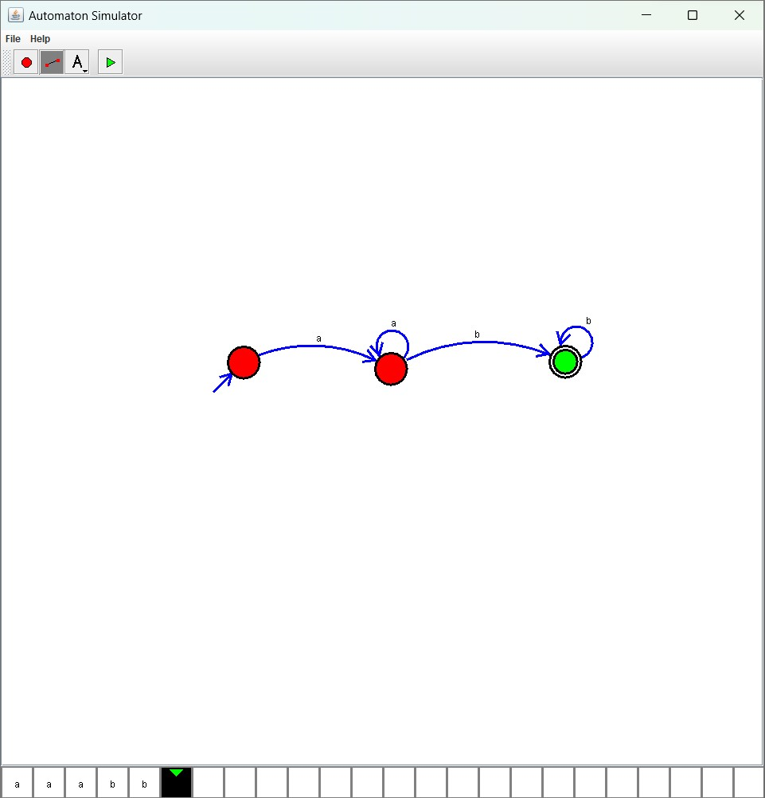

Result :

The simulator is accepted the string that start and end with different symbols over the input {a,b}by using the above NFA diagram